Registration in Google Docs
- From your form in Google Docs you can view and download all of the registration data to Excel. Follow these steps:
  - Click on the RESPONSES option (top-center of the form). From here you will see these options: Summary, Question, or Individual.
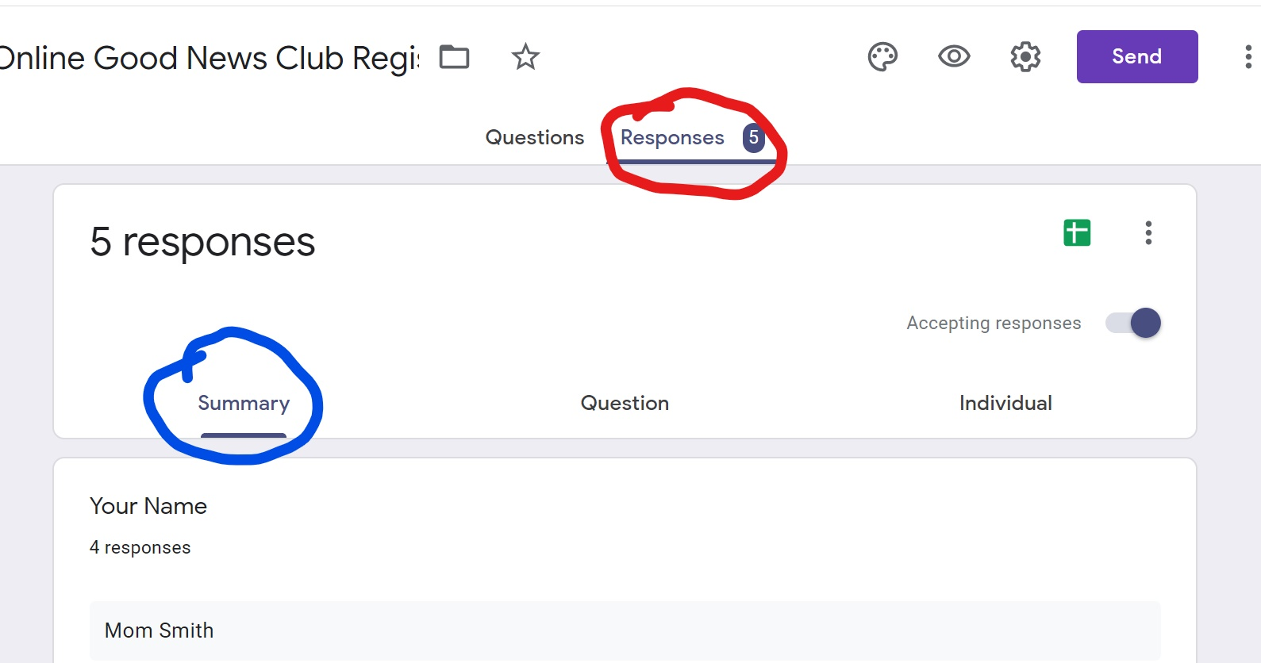

  - To start the download, look for the green and white Excel icon in the upper right-hand corner with 3 menu dots to the right. You can click on the Excel icon or click on the menu dots and then download as shown in the next step.
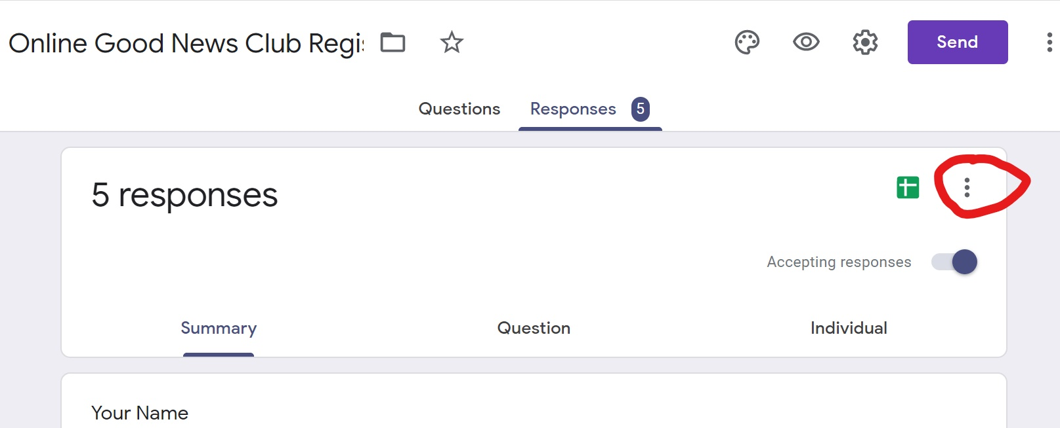

  - Click on Download Responses in the menu.
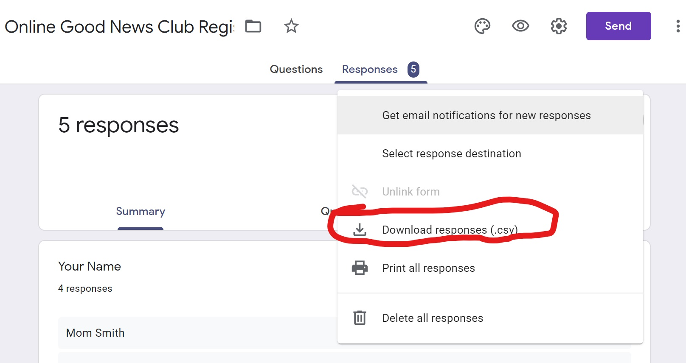
  - The download will be a “zipped” file. Click on it.
  - Save the file in your preferred location.
  - If you need to print out the roster and would like it to fit on one page, you can “hide” the columns you don’t need on the printed roster. Highlight the entire column you want to hide (e.g., timestamp, signature, date, etc.) and right-click, then choose Hide. This will hide the columns until you unhide them. None of the data will be deleted. You may also need to reduce the font and the margins.

Original downloaded spreadsheet:
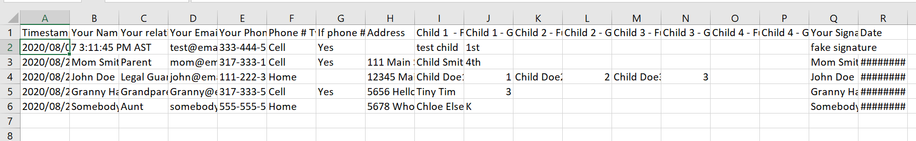

Reformatted Roster:
